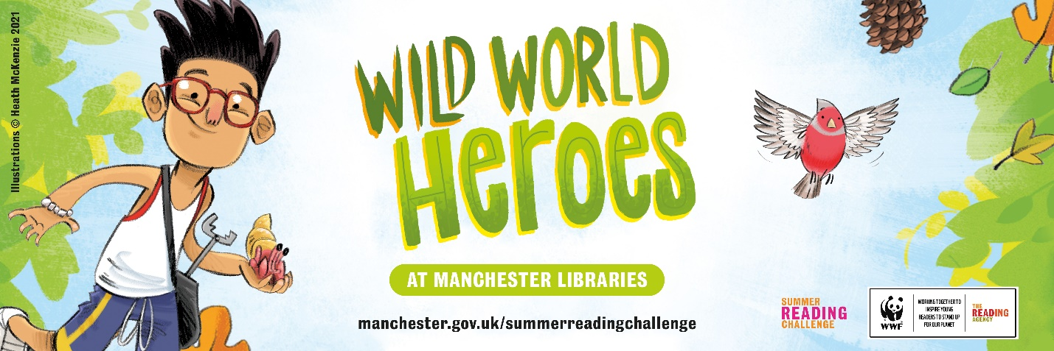

Wild World Heroes – Summer Reading Challenge 2021

What is the Summer Reading Challenge?
The Summer Reading Challenge is a challenge for children to read six library books (or more) over the holidays. It runs until 18 September in all Manchester Libraries. It is a great opportunity to share and talk about books as a family and to celebrate your child’s reading achievements. Joining a Challenge is a great way to keep motivated too.
Every year there is a great theme and this year there’s a nature-themed challenge - ‘Wild World Heroes.’ With the help of your child’s school, Manchester Libraries are inviting children to come along and join up – and it’s all free!
When children join the Challenge there are free gifts and after reading six books they receive a medal too!

So how does your child join?
- Sign up for the Challenge at your local library from 5 July
- Your child will be given a special Wild World Heroes collector poster
- Read at least six library books and collect stickers and rewards.
- They receive a certificate and medal when they finish - it’s fun and totally free
And if they’re not already library members, it’s easy to join – just go along to your local library or head online at www.manchester.gov.uk/libraries. You could join too – it's all free! Our 22 Manchester libraries have a great selection of books, and you can borrow books online too.

Why join the Summer Reading Challenge?
- It supports children’s studies. We know that reading for fun improves literacy
- Reading for pleasure is one of the most important factors for children’s academic success
- Studies show that a love of reading in children can help their wellbeing and help them cope with difficult situations
- The Challenge gives children the chance to join thousands of other children across the country, reading books, sharing ideas and taking part in some great activities
- Teachers tell us that children who take part in the Challenge return to school with a new enthusiasm for reading.

Activities
Libraries will once again be offering free activities during the summer. To find out more about these and other activities for children, check out LoadstoDo

Prizes and competitions
When your child completes the Challenge (by reading 6+ books), they will be entered into a prize draw to win vouchers and books. There is also a book review competition to win a Kindle Fire and book bundles.
Go to www.manchester.gov.uk/summerreadingchallenge or see Facebook @manchesterlibraries to find out more.

